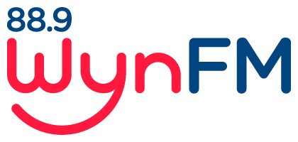

Diversity Policy

Community Radio Broadcasting
Codes of Practice: Code 2: Principles of diversity and independence

Review: May 2022

WYNFM Diversity Policy

WynFM Community Radio Inc is welcoming and we seek to include Members from all areas of our community.

- People with a disability

Wherever possible, we will make reasonable modifications to enable participation in WynFM broadcasting activities as far as reasonably practicable.

- People from diverse cultures

WynFM will support and respect people from diverse cultures and religions to participate in our station and where possible accommodate requests for flexibility.

- Sexual & Gender Identity

All people, regardless of their gender and sexuality, are welcome at WynFM.

WynFM strives to provide a safe environment for participation and will take action over any inappropriate behaviour displayed towards someone on the basis of ethnicity, race, language, gender, sexuality, age, physical or mental ability, occupation, religious, cultural or political beliefs.

Documents relating to this Policy

Community Broadcasting Codes of Practice:
Code 2. Principles of diversity and Independence
Code 3. General Programming
WynFM Community Radio Inc Constitution
WynFM Community Radio Inc Policies
- Volunteer Policy
- Complaint Policy
- Internal Grievance Policy
- Anti-Bulling Policy
- Anti Discrimination and Harassment Policy
- Social Media Policy
- Computer and Internet Usage
- Health and Safety Policy
- Community Engagement Policy

